**Conventions:**

* Tilt angle in horizontal flight is set as 0o and in vertical flight as 90o.

**Mathematical Model:**

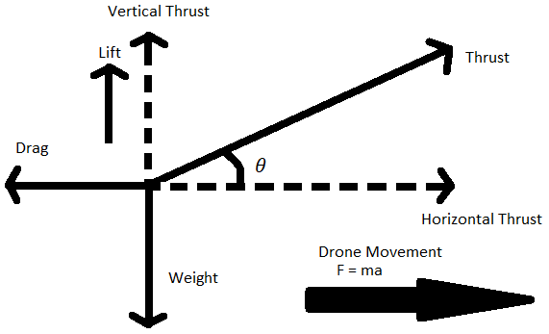For simplicity, we assume that thrust magnitude during the transition phase remain constant and only the tilt angle changes. Thrust provided by rotors is divided into vertical and horizontal components depending on the instantaneous tilt angle.

Treating the thrust force as an impulse during transition a relationship between the tilt angle and force was obtained. Knowing that the vertical and horizontal forces vary with a cos and sin functions respectively the following conclusions were made:

Maple® was used to plot these functions and hit-and-trail method was employed to reach a physically feasible solution. By deploying 2.5kg thrust from each motor and a tilting rate of 0.794 rad/s the final horizontal velocity achieved is 16.25 m/s which is the ideal cruise velocity for this UAV during the initial transition state.

To calculate the distance covered during this state:

**Conclusion:**

It was seen that the model was valid up till 110N force which was well within our operation range. Also, a decrease in thrust resulted in an increased angular velocity. The thrust was limited by the motor power and efficiency whereas the angular velocity was limited by servo power and stability. As such, an efficient solution had to be reached for transition state dynamics. Similar method was employed to calculate all transition states activities.